Health History Information
Name: ___________________________________ Date: ____/______/____
Address: _________________________________________
City: _________________ State: __________ Zip: ___________________
Date of Birth: _____/______/______ Email: ________________________________
Home Phone: ________________________ Cell/Work: __________________________
Occupation: _____________________________________________________
How did you hear about us? ______________________________________________________
Emergency Contact: _________________________ Phone: ___________________________
Physician: ____________________________ Chiropractor: ______________________
Are you currently under any medical supervision? If so, please explain:
______________________________________________________________________________
Medications: ________________________________________________________________
Surgeries: ____________________________________________________________________
Recent Injuries: ______________________________________________________________
Have you received massage therapy before? Yes No
If yes, how long ago? ________________________________________________________

Current Health Information
Check any of the following that apply to you presently or recently:
___ Acne ___Allergies: to what? _______________________
___Aids ___Arthritis: what type? _____________________
___Athletes Foot ___Cancer: what type? ______________________
___Carpal Tunnel in remission? Yes No
___Chronic Pain ___Diabetes: Type: ___________
___Constipation ___Fractures: where? _______________________
___Depression/Anxiety ___Headaches: frequency: ____________________
___Eczema ___Pregnancy (current): Weeks: _______________
___Fibromyalgia ___Kidney or Lung Disease
___Heart Disease ___Sprain/Strain/Dislocation
___High Blood Pressure ___Stroke: Date: _______________
___Joint/Back Problems/Tension ___Thyroid Disorder: Hyper Hypo
___History of Blood Clots ___ Other: ________________________________

Preferred Conversation Level
___About My Health Care Only ___Minimal Casual Conversation ___No Preference

Please Turn Over……

What is your reason for treatment today? ____________________________________________________________________________________________________________________________________________________________

Place an “X” below on areas of tenderness or discomfort.
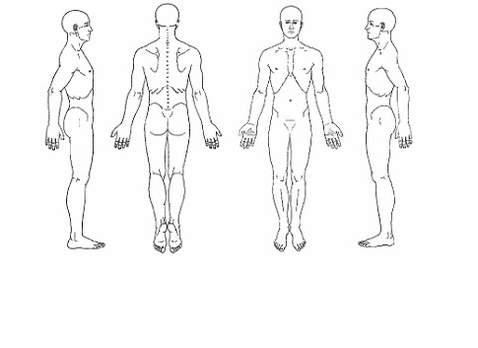

Initial each of the following if you agree:
____ 8 HOUR CANCELLATION POLICY: I understand that I am responsible for a $30 fee in the event that I am unable to provide 8 hour notice prior to my appointment. In the event that I miss a scheduled massage I will be billed at the current rate. I agree to these terms and understand that my account will be billed under the conditions stated.
____ LATE POLICY: I understand that if I am late for my scheduled appointment, that time will be deducted from my session and I will be charged for the full session.
____ I understand that chiropractic health care services are offered by a licensed Doctor of Chiropractic, but are in no way practiced by massage therapists, including the practice of medicine. Client records and transactions with the practitioner are confidential.
____ I understand that the therapist has the right to refuse service to anyone due to inappropriate behavior or misconduct and can stop a session at any time. The massage therapist reserves the right to charge for the session time whether or not the services were rendered

CONSENT FOR CARE
It is my choice to receive manual massage therapy and I give my consent to receive treatment. I have reported all health conditions that I am aware of and will inform my therapist of any changes in my health.

Signature: _____________________________________________ Date: ____/_____/_____

